Software Requirements
Specification

for

PetroPulse
Petrol Station
Management System

Prepared by

Anas Bin Rashid 22I-0907
Adan Malik 22I-1000
Hasnain Akhtar 22I-1241

April 20, 2025

Product Backlog/User Stories

ID | User Story | Acceptance Criteria | Estimation | Priority
1 | User Registration - As a new user, I want to register on the system so that I can access PetroPulse services. | Given: A new user navigates to the registration page. When: They provide valid details (name, email, phone, password). Then: The system successfully creates an account and sends a confirmation email. | 3 | High
2 | User Login - As a registered user, I want to log into the system so that I can access my dashboard. | Given: A user is on the login page. When: They enter valid credentials. Then: The system grants access to their dashboard. | 2 | High
3 | Password Reset - As a user, I want to reset my password so that I can regain access to my account if I forget it. | Given: A user is on the login page. When: They click on "Forgot Password" and enter their email. Then: The system sends a password reset link to their email. | 3 | Medium
4 | Add Fuel Station - As an owner, I want to add new fuel stations so that I can manage multiple stations in the system. | Given: An owner is logged in. When: They enter station details and submit the form. Then: The system registers the new station and updates the list. | 3 | High
5 | View Fuel Stations - As an owner, I want to view a list of my fuel stations so that I can manage their operations efficiently. | Given: The owner is on the dashboard. When: They navigate to the "Manage Stations" section. Then: The system displays a list of owned stations. | 2 | High
6 | Update Fuel Station Details - As an owner, I want to update my fuel station details so that I can keep the information accurate. | Given: The owner is on the "Manage Stations" page. When: They update station details and save changes. Then: The system reflects the updated details. | 3 | Medium
7 | Remove Fuel Station - As an owner, I want to remove a fuel station so that I can stop managing a closed or sold station. | Given: The owner is on the "Manage Stations" page. When: They click delete and confirm the action. Then: The system removes the station from the database. | 3 | Medium
8 | Register Workers - As a station owner, I want to register workers so that they can manage station activities. | Given: The owner is on the "Manage Workers" page. When: They enter the worker's details and submit. Then: The system registers the worker. | 3 | High
9 | Assign Workers to Stations - As an owner, I want to assign workers to specific stations so that they can operate in their designated locations. | Given: An owner is on the worker management page. When: They select a worker and assign a station. Then: The system updates the worker's assigned station. | 3 | Medium
10 | Worker Login - As a worker, I want to log into the system so that I can manage station operations. | Given: A worker is on the login page. When: They enter valid credentials. Then: The system grants access to the worker dashboard. | 2 | High
11 | Record Fuel Sales - As a worker, I want to record fuel sales so that the system tracks all transactions. | Given: A worker is logged in. When: They enter fuel sale details. Then: The system stores the transaction. | 3 | High
12 | Generate Sales Reports - As an owner, I want to generate sales reports so that I can analyze revenue and performance. | Given: The owner is on the reports page. When: They select a date range and generate a report. Then: The system displays the sales data. | 3 | High
13 | Track Fuel Inventory - As a station owner, I want to track fuel levels so that I can ensure continuous supply. | Given: The owner is on the dashboard. When: They check the station inventory. Then: The system displays real-time fuel levels. | 4 | High
14 | Alert for Low Fuel Levels - As a station owner, I want to receive alerts for low fuel levels so that I can order refills in time. | Given: A station's fuel level drops below a threshold. When: The system detects the low level. Then: It sends an alert to the owner. | 3 | High
15 | Order Fuel Supply - As an owner, I want to order fuel refills so that my stations never run out of stock. | Given: The owner is on the fuel supply page. When: They place an order for fuel. Then: The system processes and confirms the order. | 4 | High
16 | View Loyalty Points - As a customer, I want to view my loyalty points so that I can track my rewards. | Given: A customer is logged in. When: They navigate to the "Loyalty Points" page. Then: The system displays their current balance. | 2 | Medium
17 | Redeem Loyalty Points - As a customer, I want to redeem my loyalty points so that I can get fuel discounts. | Given: A customer has sufficient points. When: They redeem them at checkout. Then: The system applies the discount. | 3 | Medium
18 | Customer Fuel Purchase - As a customer, I want to purchase fuel from the station so that I can refuel my vehicle. | Given: A customer is at a station. When: They choose the fuel type, quantity, and payment method. Then: The system processes the payment and updates inventory. | 4 | High
19 | Manage Pricing for Fuel Types - As a station owner, I want to update fuel prices so that I can adjust them based on market conditions. | Given: The owner is on the pricing page. When: They update the price of a fuel type. Then: The system reflects the new pricing in real time. | 3 | High
20 | Manage Maintenance Requests - As a station owner, I want to log maintenance requests so that I can ensure station upkeep. | Given: A station has an issue. When: The owner submits a maintenance request. Then: The system records and tracks the request. | 3 | Medium
21 | View Transaction History - As a customer, I want to view my transaction history, so that I can track my fuel purchases. | Given: A customer is logged in,  When: They navigate to the transactions section,  Then: The system displays all past fuel purchases. | 2 | Medium
22 | Payment via Cash - As a customer, I want to pay for fuel using cash, so that I can complete my purchase without a card. | Given: A customer selects fuel,  When: They choose cash as the payment method,  Then: The system registers the payment and updates records. | 3 | High
23 | Payment via Card - As a customer, I want to pay for fuel using my debit/credit card, so that I can make transactions easily. | Given: A customer selects fuel,  When: They choose card as the payment method,  Then: The system processes the payment and updates records. | 3 | High
24 | Manage Supplier Information - As an owner,  I want to manage my fuel suppliers,  So that I can track orders and deliveries. | Given: The owner is on the supplier management page,  When: They add, edit, or remove a supplier,  Then: The system updates the supplier database. | 3 | Medium
25 | Generate Maintenance Reports - As an owner,  I want to track station maintenance, so that I can schedule repairs and ensure smooth operations. | Given: The owner is on the reports page,  When: They request a maintenance report,  Then: The system provides a list of past and upcoming maintenance tasks. | 3 | Medium
26 | Employee Attendance Tracking - As a station owner,  I want to track employee attendance, so that I can monitor working hours. | Given: A worker logs into the system,  When: They mark attendance for the shift,  Then: The system records their working hours. | 3 | Medium
27 | Secure Access - As a user,  I want to have secure access to system configurations, so that I can manage system settings safely. | Given: The user is on the login page,  When: They enter valid admin credentials,  Then: The system grants access to the admin panel. | 3 | High
28 | View Worker Profiles - As an owner, I want to view worker profiles, so I can manage their information and roles. | Given: The owner is on the "Manage Workers" page. When: They select a worker profile. Then: The system displays the worker's details. | 2 | Medium

Team Member Roles

Product Owner – Hasnain Akhtar
Responsibilities:
- Define and prioritize user stories for the Petroleum Management System.
- Ensure that features such as fuel request handling, inventory tracking, and payment processing align with stakeholder needs.
- Communicate business requirements clearly to the development team.
- Accept or reject completed user stories based on their adherence to acceptance criteria.
- Continuously refine the backlog based on feedback from stakeholders and the development team.

Scrum Master – Anas Bin Rashid
Responsibilities:
- Facilitate Agile ceremonies such as Sprint Planning, Daily Standups, Sprint Review, and Retrospective.
- Identify and remove blockers affecting the development of features like shift management, employee check-in, and real-time alerts.
- Ensure smooth collaboration between Hasnain (Product Owner) and Adan (Developer).
- Track sprint progress and ensure adherence to Agile principles.
- Guide the team in improving workflow efficiency and maintaining high productivity.

Scrum Team – Adan Malik, Anas Bin Rashid, Hasnain Akhtar
Responsibilities:
- Develop and implement features such as fuel request processing, analytics dashboard, and customer profile management.
- Ensure code quality, security, and efficiency while integrating various modules.
- Conduct unit testing and debugging to ensure smooth system functionality.
- Collaborate with Hasnain (Product Owner) to clarify feature requirements and address feedback.
- Participate in sprint planning and daily standups to track development progress.

Sprint Details

Total number of Sprints are 3, and their details are as follows.

Sprint 3

1. Sprint Overview
- Objective : The goal of Sprint 3 is to implement features related to customer fuel purchases, loyalty point redemption, fuel pricing management, maintenance requests, transaction history, payment methods (cash/card), supplier management, maintenance reports, and employee attendance tracking.
- Scope of Work :
  - Redeem Loyalty Points
  - Customer Fuel Purchase
  - Manage Pricing for Fuel Types
  - Manage Maintenance Requests
  - View Transaction History
  - Payment via Cash/Card
  - Manage Supplier Information
  - Generate Maintenance Reports
  - Employee Attendance Tracking
- Duration : 2 weeks

2. Sprint Backlog
Modules Worked On
- Customer Features :
  - Redeem Loyalty Points
  - Customer Fuel Purchase
  - View Transaction History
  - Payment via Cash/Card
- Owner Features :
  - Manage Pricing for Fuel Types
  - Manage Maintenance Requests
  - Manage Supplier Information
  - Generate Maintenance Reports
  - Employee Attendance Tracking
User Stories and Sub-User Stories
User Story 17 – Redeem Loyalty Points
- Title : Redeem Loyalty Points
- As a customer , I want to redeem my loyalty points so that I can get fuel discounts.
- Context / Note : This story ensures that customers can apply their loyalty points during checkout.
- Task :
  - Create a "Redeem Points" option at checkout.
  - Validate sufficient points before applying the discount.
  - Deduct redeemed points from the customer's account.
  - Update the transaction record with the applied discount.
- Subtask List :
  - [Add "Redeem Points" button to checkout UI]
  - [Validate sufficient points before redemption]
  - [Apply discount and update transaction record]
  - [Deduct points from the customer's account]
- Associated User Stories :
  - User Story 16 : View Loyalty Points
- Rule : Redemption cannot exceed available points.
- ID : US-17

User Story 18 – Customer Fuel Purchase
- Title : Customer Fuel Purchase
- As a customer , I want to purchase fuel from the station so that I can refuel my vehicle.
- Context / Note : This story allows customers to select fuel type, quantity, and payment method.
- Task :
  - Create a fuel purchase form.
  - Process payment via cash or card.
  - Deduct purchased fuel from inventory.
  - Generate a transaction receipt.
- Subtask List :
  - [Create fuel purchase form UI]
  - [Process payment and update records]
  - [Deduct fuel from inventory]
  - [Generate transaction receipt]
- Associated User Stories :
  - User Story 22 : Payment via Cash
  - User Story 23 : Payment via Card
- Rule : Inventory levels must update in real time.
- ID : US-18

User Story 19 – Manage Pricing for Fuel Types
- Title : Manage Pricing for Fuel Types
- As a station owner , I want to update fuel prices so that I can adjust them based on market conditions.
- Context / Note : This story allows owners to modify fuel prices dynamically.
- Task :
  - Create a pricing management page.
  - Validate new price inputs.
  - Reflect updated prices in real time.
- Subtask List :
  - [Create pricing management UI]
  - [Validate new price inputs]
  - [Update prices in the database]
- Associated User Stories :
  - User Story 18 : Customer Fuel Purchase
- Rule : Price changes must reflect immediately.
- ID : US-19

User Story 20 – Manage Maintenance Requests
- Title : Manage Maintenance Requests
- As a station owner , I want to log maintenance requests so that I can ensure station upkeep.
- Context / Note : This story allows owners to submit and track maintenance requests.
- Task :
  - Create a maintenance request form.
  - Log requests with timestamps.
  - Track request status (open/closed).
- Subtask List :
  - [Create maintenance request form UI]
  - [Log requests with timestamps]
  - [Track request status]
- Associated User Stories :
  - User Story 25 : Generate Maintenance Reports
- Rule : Requests must be logged accurately.
- ID : US-20

User Story 21 – View Transaction History
- Title : View Transaction History
- As a customer , I want to view my transaction history, so that I can track my fuel purchases.
- Context / Note : This story allows customers to review their past transactions.
- Task :
  - Fetch transaction data from the database.
  - Display transaction details (date, amount, station, payment type).
- Subtask List :
  - [Fetch transaction data from MongoDB]
  - [Display transaction details on the UI]
- Associated User Stories :
  - User Story 18 : Customer Fuel Purchase
- Rule : Data must be restricted to the logged-in customer.
- ID : US-21

User Story 22 – Payment via Cash
- Title : Payment via Cash
- As a customer , I want to pay for fuel using cash, so that I can complete my purchase without a card.
- Context / Note : This story handles cash payments and updates records accordingly.
- Task :
  - Add a "Cash" payment option.
  - Register cash payments and update inventory.
- Subtask List :
  - [Add "Cash" payment option to checkout UI]
  - [Register cash payments and update records]
- Associated User Stories :
  - User Story 18 : Customer Fuel Purchase
- Rule : Payments must be recorded accurately.
- ID : US-22

User Story 23 – Payment via Card
- Title : Payment via Card
- As a customer , I want to pay for fuel using my debit/credit card, so that I can make transactions easily.
- Context / Note : This story integrates card payment processing.
- Task :
  - Add a "Card" payment option.
  - Validate card details and process payment.
- Subtask List :
  - [Add "Card" payment option to checkout UI]
  - [Validate card details and process payment]
- Associated User Stories :
  - User Story 18 : Customer Fuel Purchase
- Rule : Payment failures must be handled gracefully.
- ID : US-23

User Story 24: Manage Supplier Information
Title :
Manage Supplier Information
As a station owner ,
I want to manage my fuel suppliers so that I can track orders and deliveries effectively.
Context / Note :
This story allows station owners to add, edit, or remove supplier details. It ensures that supplier information is accurate and up-to-date for managing fuel orders and deliveries.
Task :
- Create a form for entering supplier details (e.g., name, contact information, delivery terms).
- Validate input fields before saving changes.
- Store supplier data in the database.
- Prevent deletion of suppliers linked to active orders.
Subtask List :
- [Create supplier management form UI]
- [Validate input fields (name, contact, delivery terms)]
- [Add functionality to create, edit, and delete suppliers]
- [Prevent deletion of suppliers with active orders]
- [Log all supplier modifications for auditing purposes]
Associated User Stories :
- User Story 15 : Order Fuel Supply
Rules :
- Suppliers cannot be deleted if they are linked to active orders.
- All modifications to supplier data must be logged for auditing.
ID : US-24

User Story 25: Generate Maintenance Reports
Title :
Generate Maintenance Reports
As a station owner ,
I want to track station maintenance so that I can schedule repairs and ensure smooth operations.
Context / Note :
This story enables owners to generate reports for past and upcoming maintenance tasks. The reports help in planning and ensuring timely repairs to avoid operational disruptions.
Task :
- Create a form for selecting filters (e.g., station, time period).
- Fetch maintenance data from the database based on selected filters.
- Display aggregated data (e.g., task description, date, status) in a table or chart.
- Allow exporting reports in standard formats like PDF or CSV.
Subtask List :
- [Create maintenance report generation UI]
- [Add filters for station and time period]
- [Fetch and display aggregated maintenance data]
- [Implement export functionality for PDF/CSV]
Associated User Stories :
- User Story 20 : Manage Maintenance Requests
Rules :
- Reports must include all maintenance tasks within the selected filters.
- Exported reports should be formatted for readability.
ID : US-25

User Story 26: Employee Attendance Tracking
Title :
Employee Attendance Tracking
As a station owner ,
I want to track employee attendance so that I can monitor working hours and ensure accountability.
Context / Note :
This story allows workers to mark their attendance at the start of their shifts. The system records their login time and calculates working hours for payroll and performance tracking.
Task :
- Add an "Attendance" feature to the worker dashboard.
- Record login timestamps when workers mark attendance.
- Calculate total working hours for each shift.
- Provide attendance history to the owner for review.
Subtask List :
- [Add "Mark Attendance" button to the worker dashboard]
- [Record login timestamps in the database]
- [Calculate and display total working hours]
- [Provide attendance history to the owner]
Associated User Stories :
- User Story 8 : Register Workers
- User Story 9 : Assign Workers to Stations
Rules :
- Attendance marking should only be allowed during valid user sessions.
- Owners should have access to detailed attendance logs for each worker.
ID : US-26

3. Software Testing
1. Supplier Details Page – Test Design
Fields:
- Supplier Name
- Company Name
- Contact Number
- Email
- Fuel Type (Dropdown: Petrol, Diesel, etc.)
- Supply Capacity (Liters)

Field-Wise Analysis and Test Design (Supplier Details Page)
Field | Input Criteria | Valid Equivalence Class | Invalid Equivalence Class | Boundary Values
Supplier Name | Alphabetic, 3–50 characters | John Smith | <3, >50, digits/special chars | 2 (invalid), 3 (valid), 50 (valid), 51 (invalid)
Company Name | Alphanumeric, 3–100 characters | FuelCorp Pvt Ltd | <3, >100, symbols only | 2 (invalid), 3 (valid), 100 (valid), 101 (invalid)
Contact Number | Exactly 10 digits, numeric only | 9876543210 | <10, >10 digits, non-numeric | 9 (invalid), 10 (valid), 11 (invalid)
Email | Valid email format | supplier@mail.com | Missing @, domain errors | Structure-based
Fuel Type | Predefined values only | Petrol, Diesel | Any non-listed string like Gasoline, blank | Not applicable
Supply Capacity | Integer between 1000 and 500000 | 15000 | <1000, >500000, negative | 999 (invalid), 1000 (valid), 500000 (valid), 500001 (invalid)

Weak Equivalence Class Testing (Supplier Details Page)
Field | Test Case ID | Test Input | Expected Result | Remarks
Supplier Name | SPD-NAME-WEAK-01 | Alfa | Accepted | Valid
Supplier Name | SPD-NAME-WEAK-02 | J@ | Rejected | Too short & invalid characters
Company Name | SPD-COMP-WEAK-01 | PowerFuel Ltd | Accepted | Valid
Company Name | SPD-COMP-WEAK-02 | !! | Rejected | Invalid input
Contact Number | SPD-CON-WEAK-01 | 9988776655 | Accepted | Valid 10-digit number
Contact Number | SPD-CON-WEAK-02 | 1234abcd | Rejected | Alphanumeric
Email | SPD-EMAIL-WEAK-01 | valid@supply.com | Accepted | Valid format
Email | SPD-EMAIL-WEAK-02 | invalid.com | Rejected | No @
Fuel Type | SPD-FUEL-WEAK-01 | Diesel | Accepted | Dropdown value
Fuel Type | SPD-FUEL-WEAK-02 | LPG | Rejected | Not in allowed options
Supply Capacity | SPD-CAP-WEAK-01 | 250000 | Accepted | Valid
Supply Capacity | SPD-CAP-WEAK-02 | -500 | Rejected | Negative

Strong Equivalence Class Testing (Supplier Details Page)
Field | Test Case ID | Test Input | Expected Result | Remarks
Supplier Name | SPD-STRONG-01 | FuelMaster | Accepted | Valid
Supplier Name | SPD-STRONG-02 | AB | Rejected | Too short
Supplier Name | SPD-STRONG-03 | A x 51 | Rejected | Too long
Company Name | SPD-STRONG-04 | FuelWorks Ltd | Accepted | Valid
Company Name | SPD-STRONG-05 | FW | Rejected | <3 chars
Company Name | SPD-STRONG-06 | A x 101 | Rejected | >100 chars
Contact Number | SPD-STRONG-07 | 9999999999 | Accepted | Valid
Contact Number | SPD-STRONG-08 | 12345678 | Rejected | Too short
Email | SPD-STRONG-09 | a@b.c | Accepted | Valid minimal email
Email | SPD-STRONG-10 | @domain.com | Rejected | Missing local part
Fuel Type | SPD-STRONG-11 | Petrol | Accepted | Valid selection
Fuel Type | SPD-STRONG-12 | PremiumFuel | Rejected | Not in options
Supply Capacity | SPD-STRONG-13 | 999 | Rejected | Below range
Supply Capacity | SPD-STRONG-14 | 1000 | Accepted | Min valid
Supply Capacity | SPD-STRONG-15 | 500001 | Rejected | Above max

Boundary Value Analysis (Supplier Details Page)
Field | Test Case ID | Input Length/Value | Test Input | Expected Result
Supplier Name | BVA-SPD-NAME-01 | 2 | AB | Rejected
Supplier Name | BVA-SPD-NAME-02 | 3 | ABC | Accepted
Supplier Name | BVA-SPD-NAME-03 | 50 | A x 50 | Accepted
Supplier Name | BVA-SPD-NAME-04 | 51 | A x 51 | Rejected
Supply Capacity | BVA-SPD-CAP-01 | 999 | 999 | Rejected
Supply Capacity | BVA-SPD-CAP-02 | 1000 | 1000 | Accepted
Supply Capacity | BVA-SPD-CAP-03 | 500000 | 500000 | Accepted
Supply Capacity | BVA-SPD-CAP-04 | 500001 | 500001 | Rejected

Summary (Supplier Details Page)
- Weak EC Tests: 12
- Strong EC Tests: 15
- BVA Tests: 8
- Total Test Cases: 35

2. Reports Generation Page – Test Design
Fields/Filters:
- Date Range (Start Date, End Date)
- Report Type (Dropdown: Sales, Supply, Expense, etc.)
- Station Filter (Dropdown or search by station name)
- Export Format (Radio or dropdown: PDF, Excel, CSV)

Field-Wise Analysis and Test Design (Reports Page)
Field | Input Criteria | Valid Equivalence Class | Invalid Equivalence Class | Boundary Values
Start Date | Must be a valid past date | 2023-01-01 | Future date, invalid format | N/A
End Date | Valid date ≥ start date | 2023-01-31 (after start) | Before start date, invalid format | N/A
Report Type | Predefined values only | Sales, Supply | Earnings, blank | N/A
Station Filter | Alphanumeric, 3–50 characters | Main Station | <3 or >50, symbols only | 2 (invalid), 3 (valid), 50 (valid), 51 (invalid)
Export Format | Must be PDF/Excel/CSV only | PDF, Excel | TXT, DOCX, blank | N/A

Weak Equivalence Class Testing (Reports Page)
Field | Test Case ID | Test Input | Expected Result | Remarks
Start Date | REP-DATE-WEAK-01 | 2024-01-01 | Accepted | Valid past date
Start Date | REP-DATE-WEAK-02 | 2026-01-01 | Rejected | Future date
End Date | REP-DATE-WEAK-03 | 2024-02-01 | Accepted | Valid end date after start
End Date | REP-DATE-WEAK-04 | 2023-12-01 | Rejected | Before start date
Report Type | REP-TYPE-WEAK-01 | Sales | Accepted | Predefined option
Report Type | REP-TYPE-WEAK-02 | Profit | Rejected | Not in options
Station Filter | REP-STAT-WEAK-01 | Fuel Point A | Accepted | Valid station name
Station Filter | REP-STAT-WEAK-02 | X | Rejected | Too short
Export Format | REP-EXP-WEAK-01 | PDF | Accepted | Valid format
Export Format | REP-EXP-WEAK-02 | TXT | Rejected | Invalid format

Strong Equivalence Class Testing (Reports Page)
Field | Test Case ID | Test Input | Expected Result | Remarks
Start Date | REP-STRONG-01 | 2023-10-10 | Accepted | Valid date
Start Date | REP-STRONG-02 | 2027-01-01 | Rejected | Future date
End Date | REP-STRONG-03 | Same as start date | Accepted | Boundary case
End Date | REP-STRONG-04 | Before start date | Rejected | Invalid range
Report Type | REP-STRONG-05 | Supply | Accepted | Valid
Report Type | REP-STRONG-06 | UnknownType | Rejected | Invalid
Station Filter | REP-STRONG-07 | MainFuelDepot | Accepted | Valid station
Station Filter | REP-STRONG-08 | !! | Rejected | Symbols only
Export Format | REP-STRONG-09 | Excel | Accepted | Valid format
Export Format | REP-STRONG-10 | DOC | Rejected | Not allowed

Boundary Value Analysis (Reports Page)
Field | Test Case ID | Input Length/Value | Test Input | Expected Result
Station Filter | BVA-REP-STAT-01 | 2 | AB | Rejected
Station Filter | BVA-REP-STAT-02 | 3 | ABC | Accepted
Station Filter | BVA-REP-STAT-03 | 50 | A x 50 | Accepted
Station Filter | BVA-REP-STAT-04 | 51 | A x 51 | Rejected

Summary (Reports Page)
- Weak EC Tests: 10
- Strong EC Tests: 10
- BVA Tests: 4
- Total Test Cases: 24

4. Meetings Conducted
Sprint Planning Meeting
Overview :
a. Date Time Stamp : 28 March 2025
b. Attendees :
Present | Absent
Anas Bin Rashid | -
Adan Malik | -
Hasnain Akhtar | -

Topics Discussed and Conclusions Reached :
- Defined sprint goals: Implement customer fuel purchase, loyalty point redemption, payment methods, supplier management, maintenance reports, and employee attendance tracking.
- Prioritized user stories: US-17, US-18, US-22, US-23, US-24, US-25, US-26.
- Assigned tasks to team members.
Conclusions :
- Sprint backlog finalized.
- Daily scrum schedule set for 9:00 AM daily.
Overall Duration : 1 hour

Daily Scrum Meetings
The meeting focused on different topics each day and they are reflected in the burndown chart below:
Day | Story Points Remaining (Planned) |  | Story Points Remaining (Actual) |  | Tasks Completed | Notes
Day 1 | 40 |  | 40 |  | 0 | Sprint starts; no tasks done.
Day 2 | 36 |  | 38 |  | 2 | Minor delays in setting up environments.
Day 3 | 32 |  | 35 |  | 3 | UI design for fuel station management.
Day 4 | 28 |  | 32 |  | 3 | Backend logic for payment methods.
Day 5 | 24 |  | 29 |  | 3 | Loyalty points UI completed.
Day 6 | 20 |  | 26 |  | 3 | Bug fixes during testing.
Day 7 | 16 |  | 23 |  | 3 | Supplier management feature added.
Day 8 | 12 |  | 20 |  | 3 | Testing ongoing for maintenance.
Day 9 | 8 |  | 15 |  | 3 | Leftover tasks identified.
Day 10 | 0 |  | 8 |  | 5 | Sprint ends; some tasks incomplete.
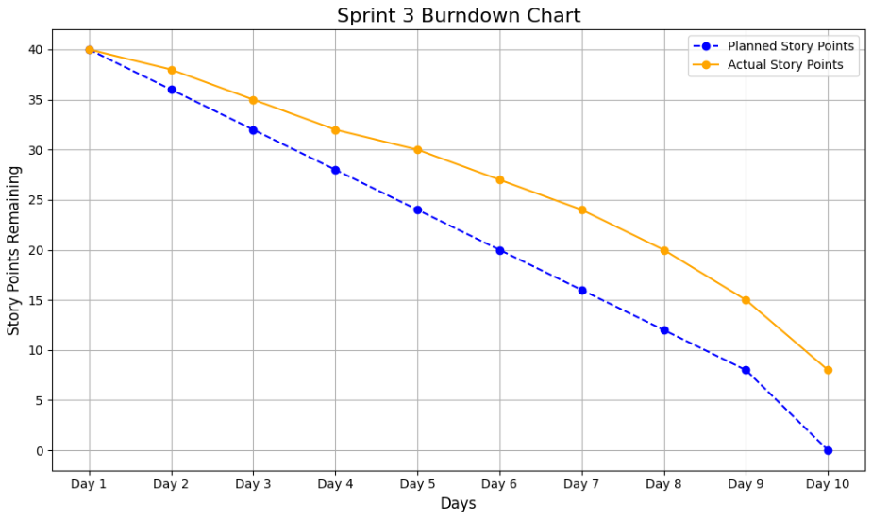

Sprint Review Meeting
Overview :
a. Date Time Stamp : 8 April 2025
b. Attendees :
Present | Absent
Anas Bin Rashid | -
Adan Malik | -
Hasnain Akhtar | -

Topics Discussed and Conclusions Reached :
- Reviewed completed user stories: US-17, US-18, US-22, US-23, US-24, US-25, US-26.
- Demonstrated working features: Loyalty point redemption, customer fuel purchase, payment methods, supplier management, maintenance reports, and employee attendance tracking.
- Identified minor bugs during testing.
Conclusions :
- All high-priority user stories completed successfully.
- Minor bugs identified during testing.
Overall Duration : 1 hour
Sprint Retrospective Meeting
Retrospective Meeting : Iteration/Sprint #2
Overview :
c. Date Time Stamp : 10 April 2025
d. Attendees :
Present | Absent
Anas Bin Rashid | -
Adan Malik | -
Hasnain Akhtar | -

Retrospective Content :
Successes | To Improve | Actions and Suggestions
Completed all high-priority user stories. | Minor delays in integrating password reset functionality. | Allocate more time for testing in future sprints.
Strong collaboration among team members. | Limited focus on edge-case testing. | Involve QA team earlier for comprehensive testing.
Well-documented codebase. | Communication gaps during task handovers. | Use Trello for better task tracking and communication.

5. Definition of Done (DoD)
- All unit tests are written.
- The written code is documented.
- Code reviewed and approved by peers.
- Features tested in staging environment.
- No critical bugs reported.

6. Bug Report
Bug Report 1
Name : Incorrect Loyalty Point Deduction During Redemption
Expected Behavior : The system should deduct the exact number of loyalty points used for a discount.
Actual Behavior : The system deducts an incorrect quantity of loyalty points, leading to discrepancies in the balance.
Steps to Reproduce :
Log in as a customer and navigate to the "Redeem Loyalty Points" page.
Redeem points for a discount at checkout.
Check the loyalty point balance after the transaction.
Context / Environment : This issue occurs in the staging environment when testing the "Redeem Loyalty Points" feature (User Story #17).
Possible Solutions :
Review backend logic for loyalty point deduction.
Add validation to prevent duplicate API calls during submission.
Definition of Done (DoD) :
All unit tests are written to verify correct loyalty point deduction.
The written code is documented.
The bug is resolved and tested in the staging environment.
Date Time Stamp : 2025-04-08 11:00 AM
Reported By : Adan Malik

Bug Report 2
Name : Employee Attendance Not Logged Correctly
Expected Behavior : The system should log the timestamp and calculate working hours accurately when a worker marks attendance.
Actual Behavior : The system logs incorrect timestamps or fails to calculate working hours correctly.
Steps to Reproduce :
Log in as a worker and mark attendance.
Check the attendance logs for the recorded timestamp and calculated working hours.
Context / Environment : This issue was identified during testing in the development environment. It is related to User Story #26.
Possible Solutions :
Debug the logic for logging timestamps and calculating working hours.
Ensure synchronization between frontend and backend timestamps.
Definition of Done (DoD) :
All unit tests are written to validate attendance logging functionality.
The written code is documented.
The bug is resolved and verified in both development and staging environments.
Date Time Stamp : 2025-04-09 03:30 PM
Reported By : Anas Bin Rashid

7. Output
Tested Code Implementation

Katalon Studio Code

import static com.kms.katalon.core.testobject.ObjectRepository.findTestObject
import com.kms.katalon.core.webui.keyword.WebUiBuiltInKeywords as WebUI

// Step 1: Open the browser and navigate to the application URL
WebUI.openBrowser('')
WebUI.navigateToUrl('http://localhost:3000/login')

// Step 2: Log in as a customer
WebUI.setText(findTestObject('Object Repository/input_Email'), 'customer@example.com')
WebUI.setText(findTestObject('Object Repository/input_Password'), 'password123')
WebUI.click(findTestObject('Object Repository/button_Login'))

// Step 3: Navigate to the "Redeem Loyalty Points" page
WebUI.click(findTestObject('Object Repository/link_Redeem_Loyalty_Points'))

// Step 4: Redeem loyalty points
WebUI.setText(findTestObject('Object Repository/input_Loyalty_Points'), '100')
WebUI.click(findTestObject('Object Repository/button_Redeem'))

// Step 5: Verify that the loyalty points were deducted
WebUI.verifyTextPresent('Loyalty points redeemed successfully.', false)

// Step 6: Close the browser
WebUI.closeBrowser()

8. Project Planner and Gantt Chart
Project Planner
- Task 1 : Set Up Project Infrastructure (Day 1–2)
  - Initialize backend project using Node.js and Express.js.
  - Install necessary dependencies (e.g., bcrypt, JWT, MongoDB driver).
  - Configure environment variables for security.
- Task 2 : Implement Customer Features (Day 3–5)
  - Redeem loyalty points (US-17).
  - Customer fuel purchase (US-18).
  - Payment via cash/card (US-22, US-23).
- Task 3 : Worker Management Features (Day 6–8)
  - Employee attendance tracking (US-26).
- Task 4 : Owner Features (Day 9–12)
  - Manage supplier information (US-24).
  - Generate maintenance reports (US-25).
- Task 5 : Testing and Integration (Day 13–15)
  - Conduct thorough testing of all implemented features.
  - Fix any bugs or issues identified during testing.

Gantt Chart
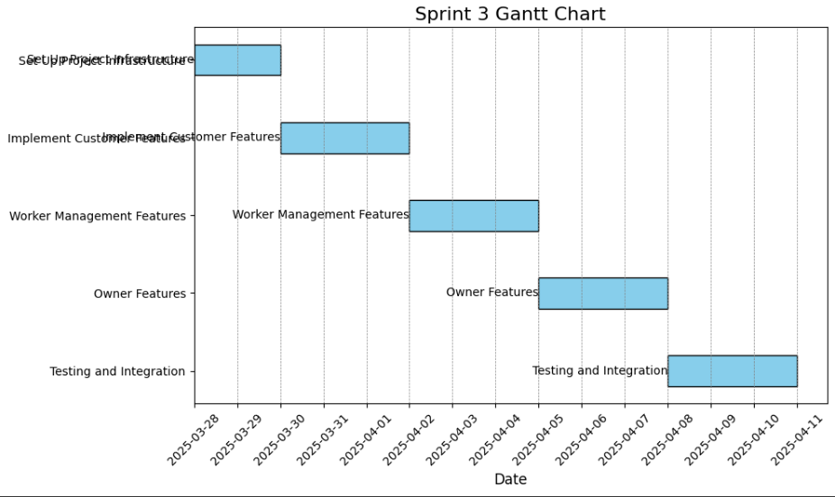
9. Trello Screenshots

Start of Sprint
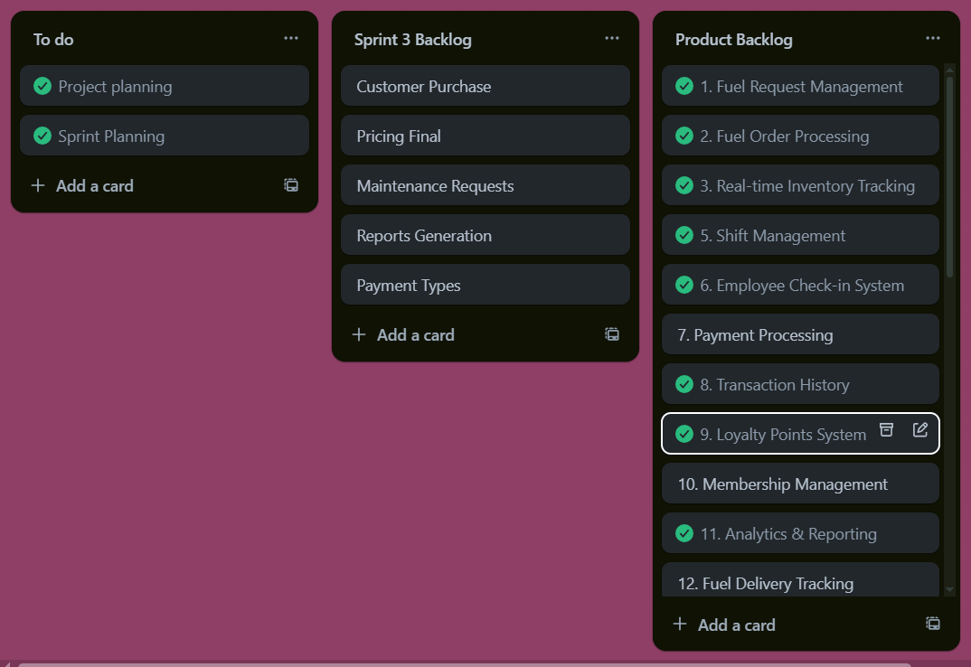

Middle of Sprint
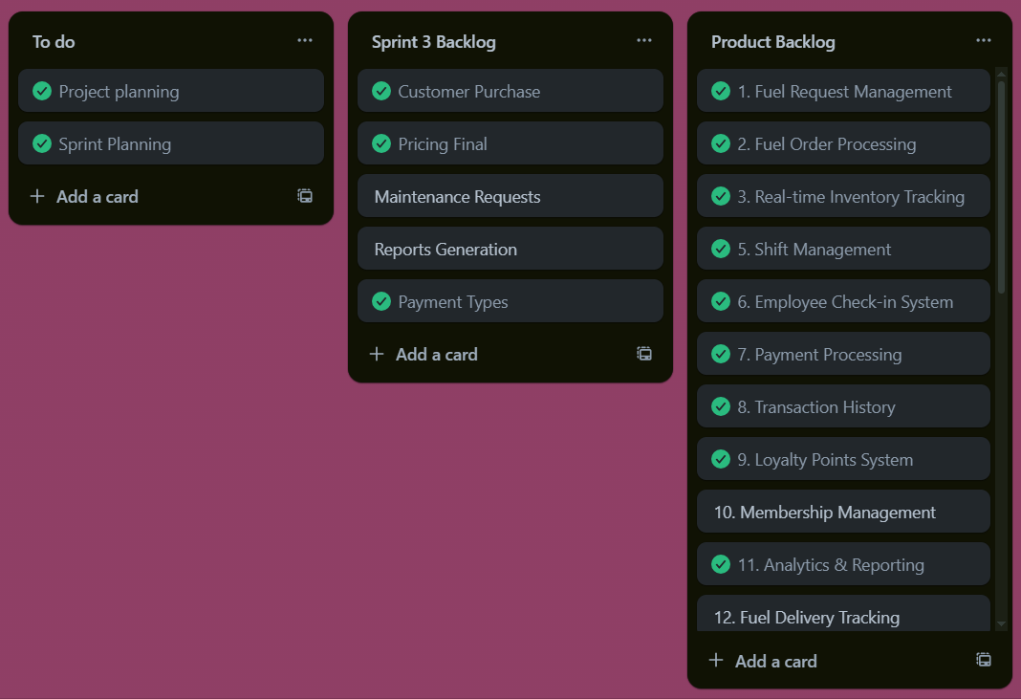

End of Sprint
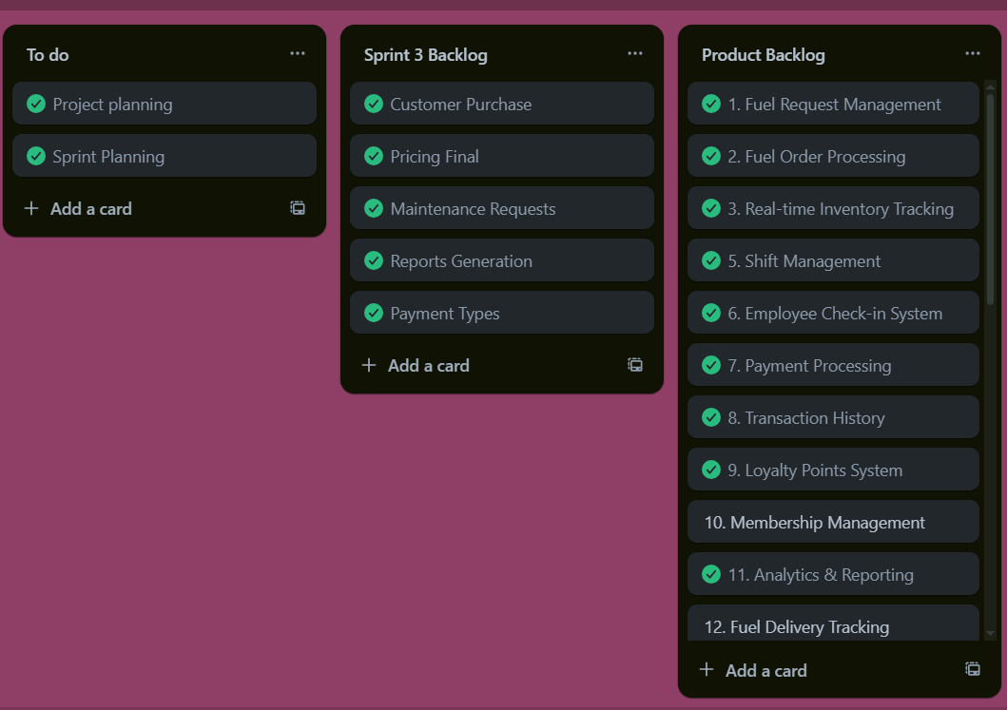

Scrum Master Activities and Leanings
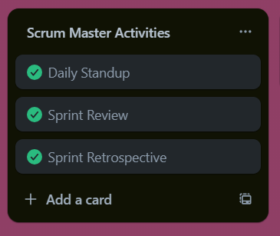
Topics Discussed and Conclusions Reached :
- Reviewed completed user stories: US-17, US-18, US-22, US-23, US-24, US-25, US-26.
- Demonstrated working features: Loyalty point redemption, customer fuel purchase, payment methods, supplier management, maintenance reports, and employee attendance tracking.
- Identified minor bugs during testing.
Conclusions :
- All high-priority user stories completed successfully.
- Minor bugs identified during testing.

10. Burndown Charts

